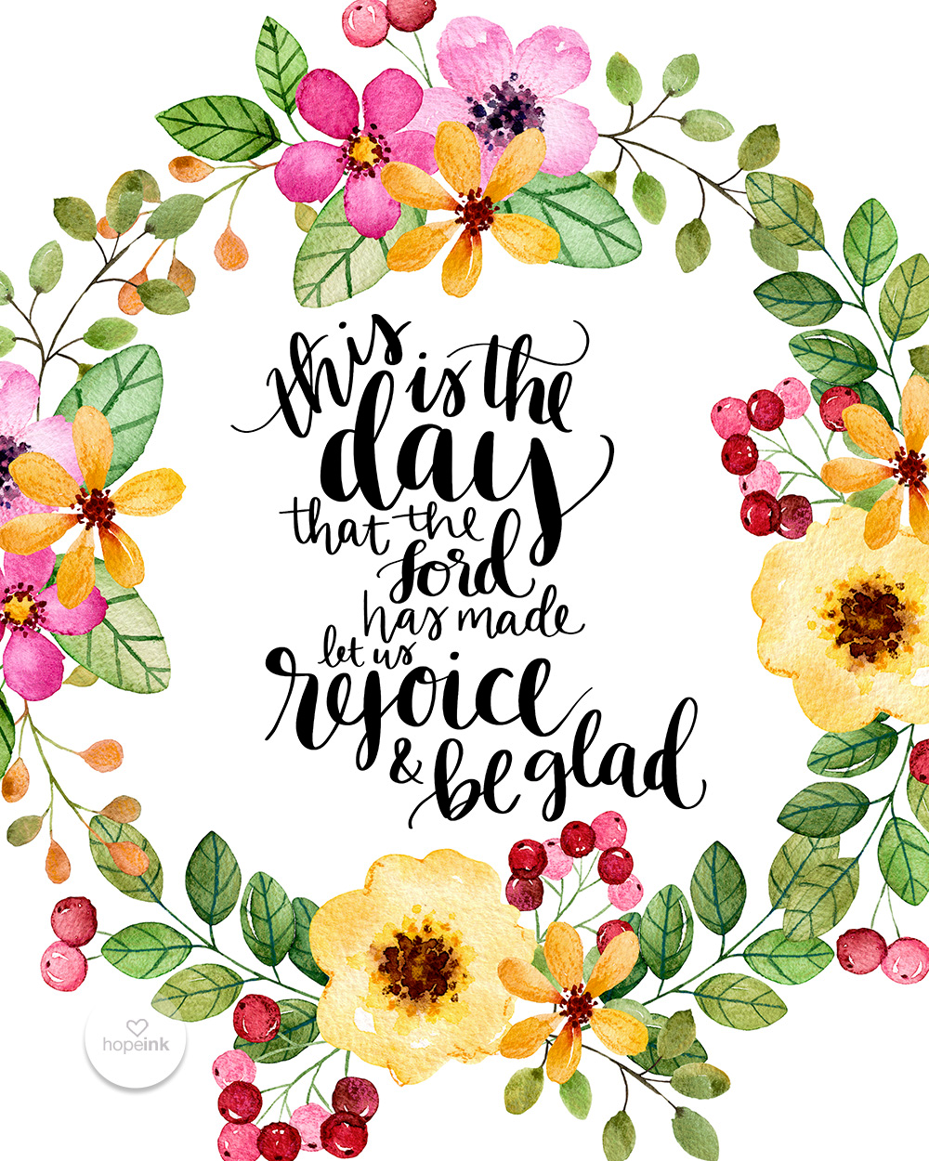

DIRECTORY OF CHESTNUT HILL UNITED METHODIST CHURCH
 | Sharma Lewis | Richmond Area Resident Bishop
 | Denise Bates | Lynchburg District Superintendent
 | Adam White | Minister
 | Steve Stadtherr | Associate Minister
 | Monica Campbell | Administrative Assistant
 | Heather Wilson | Director of Music Ministry
 | Judy Martin | Bookkeeper
 | Judy Robertson | Lay Leader


Chestnut Hill
United Methodist Church

Making disciples of Jesus Christ
for the transformation of the world.
You are welcome at Chestnut Hill UMC.

4660 Fort Avenue ~ Lynchburg, Virginia 24502
Church: 434-239-8423
Minister’s Cell: 434-944-7723, Minister’s Email: awhite@ves.org
Associate Minister’s Cell: 434-841-2458
Associate Minister’s Email: sps83.ss@gmail.com
chestnuthillumc@comcast.net ~ on the web at chestnuthillumc.net
Find us on Facebook: Chestnut Hill United Methodist Church

Chestnut Hill United Methodist Church
10:30 a.m. ~ March 20, 2022 ~ 3rd Sunday in Lent
Our ministry vision for the Virginia Annual Conference is “to be disciples of Jesus Christ who are lifelong learners, who influence others to serve.”
Welcome! Join us in worshiping God!
Prelude
Welcome and Ministry Announcements
Welcome in the name of Christ our Lord.
Thank you for silencing cell phones as we gather to worship God.
Invocation
Greeting
Bless thou the gifts our hands have brought;
Bless thou the work our hearts have planned.
Ours is the faith, the will the thought;
the rest, O God, is in thy hand. (Samuel Longfellow, 1886)
*Singing Our Faith # 127 “Guide Me, O Thou Great Jehovah”
Opening Prayer
O merciful Creator, your hand is open wide to satisfy the needs of every living creature: Make us always thankful for your loving providence; and grant that we, remembering the account that we must one day give, may be faithful stewards of your good gifts; through Jesus Christ our Lord, who with you and the Holy Spirit lives and reigns, one God, for ever and ever. Amen.
Greeting Friends and Neighbors
Prayer for Illumination
Almighty God, in you are hidden all the treasures of wisdom and knowledge. Open our eyes that we may see the wonders of your Word; and give us grace that we may clearly understand and freely choose the way of your wisdom; through Christ our Lord. Amen.

Scripture Lesson Luke 20:45-21:6
The Word of God for the people of God.
Thanks be to God.
Singing Our Faith # 381 “Savior, Like a Shepherd Lead Us”
The Good News “Letting Go”
Anthem “Gloryland Medley”
Bringing Forward God’s Tithes and Our Gifts
*Doxology # 95 Praise God from whom all blessings flow; praise him, all
Creatures here below; praise him above, ye heavenly host; praise Father, Son, and Holy Ghost. Amen.
Prayer of Thanksgiving
Sharing of Joys and Concerns
The Lord’s Prayer
Our Father, who art in heaven, hallowed be thy name. Thy kingdom come,
Thy will be done on earth as it is in heaven. Give us this day our daily bread and forgive us our trespasses, as we forgive those who trespass against us. And lead us not into temptation, but deliver us from evil. For thine is the kingdom, and the power, and the glory, forever. Amen.
*Singing Our Faith # 419 “I Am Thine, O Lord”
*Blessing and Dismissal
*Postlude

Scatter to Serve God & Neighbor
Welcome to all! We gather to praise God for the innumerable blessings given
to us and to grow deeper in the Spirit. Joyfully, let us lift our hearts to God.

**Calendar**
Sunday, 3/20 | 11:45 a.m. | Stewardship Luncheon
Thursday, 3/17 | 6:30 p.m. | Choir
Friday, 3/18 | 10:00 a.m. | Homeschool

In Memoriam
Inez Carolina Owen Tolley
May 16, 1927 – March 9, 2022
Chestnut Hill United Methodist Church extends Christian love and sympathy to the family of Inez Carolina Owen Tolley and especially to her daughter-in-law, Judy Johnson. And to her friend for many years, Beryl Martin.
Coming Up:
The Easter offering for 2022 will be for HVAC repairs for the Fellowship Hall and any additional monies will go to replenish our church maintenance fund. This year's goal is $4,000. Please consider an offering for our continuing church maintenance and restoration. It benefits all of us for our worship and social gatherings.

In the Grocery Cart This Month
For March~The homeless seeking help have increased so we are continuing with bags filled with the following: soups, canned meats, ravioli, breakfast bars and cereal. Make sure the canned goods have pop top lids so they can be opened easily.
Place donations in the grocery cart, located in the Commons.
**NOTE: Please put all liquids in the box provided. Tape down all flip top bottles. AND no “baked goods” of any kind.

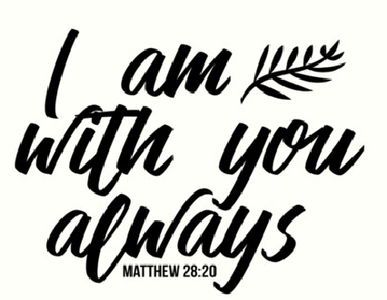

**Calendar**
Sunday, 3/20 | 11:45 a.m. | Stewardship Luncheon
Thursday, 3/17 | 6:30 p.m. | Choir
Friday, 3/18 | 10:00 a.m. | Homeschool
In Memoriam
Inez Carolina Owen Tolley
May 16, 1927 – March 9, 2022
Chestnut Hill United Methodist Church extends Christian love and sympathy to the family of Inez Carolina Owen Tolley and especially to her daughter-in-law, Judy Johnson. And to her friend for many years, Beryl Martin.
Coming Up:
The Easter offering for 2022 will be for HVAC repairs for the Fellowship Hall and any additional monies will go to replenish our church maintenance fund. This year's goal is $4,000. Please consider an offering for our continuing church maintenance and restoration. It benefits all of us for our worship and social gatherings.
In the Grocery Cart This Month
For March~The homeless seeking help have increased so we are continuing with bags filled with the following: soups, canned meats, ravioli, breakfast bars and cereal. Make sure the canned goods have pop top lids so they can be opened easily.
Place donations in the grocery cart, located in the Commons.
**NOTE: Please put all liquids in the box provided. Tape down all flip top bottles. AND no “baked goods” of any kind.

